Standard Operating Procedure
For
CREDIT CARD RECONCILIATIONS
HPI and SEG

Document History
Document Location
MHE Share Drive
Revision History Document Creation
Creation Date: | Genpact approval by: | Customer approval by:
 | Name, Title | Kathleen Luckie Dir AR Operations

Revision Date: | Version Number: | Change reason: | Pages Changed (pg. no.) | Genpact approval by: | Customer approval by:
Month d, year | 01 |  |  | Name, Title | Name, Title
06/30/2016 | 02
1/04/2017 |  | Updation |  |  | Kathleen luckie
4/13/2017 |  | Certification |  |  | Kathleen Luckie
10/24/2018 |  | Recertification |  |  | Kathleen Luckie
12/10/2019 |  | Recertification |  |  | Kathleen Luckie
09/09/2020 |  | Recertification |  |  | Kathleen Luckie

Table of Contents
1. Overview 4
1.1. Customer Overview 4
1.2. Purpose 4
1.3. Scope 4
1.4. Definitions 4
1.5. System Overview 5
1.6. Roles and Responsibilities 5
2. Process Narrative 5
3. Process Map/Flowchart 5
4 Detailed Process Steps 5
4.1. Credit Card allocation detailed report 5
4.2. Paymentech report from Orbital site 5
4.3. PayPal report from PayPal Site 5
4.4. BrainTree report from Silverchair site 6
4.5 GL report from Oracle Express Transaction Analysis 6
4.6. Matching the Cash received in GL with the Cash settled in payment sites 6
4.7. Consolidate the data from the reports in Access database 6
4.8. Reconciling and analyzing the outstanding balances with the open items with the reason 13
5. Process Exceptions Handling 18
6. Compliance control 18
7. Escalation process 18
8. Process SLAs 18
9 Related Documents 18
10. FAQ: 18
11. Sign Off. 18

- Overview
  - Customer Overview

McGraw Hill is part of Apollo Inc. a leading provider of Educational information and products. McGraw Hill was founded in 1917 and acquired by Apollo Inc. in March 2013. It provides essential information and insight that help individuals, markets, and societies perform to their potential. The primary goal of the McGraw Hill is to focus our efforts on growing globally, converging content and technology to create new higher-value offerings, and become more productive – Global growth; Digital growth; increased productivity.
  - Purpose
The purpose of this reconciliation is to ensure that the orders processed in Oracle which give access to the content or the shipment of product are reconciled against the settled receipts in the bank account. There are two reconciliations HPI & SEG. General Ledger accounts 9150-2077-999999-10311704 and 9160-2169-999999-10311704.
  - Scope
  - Definitions
    - Acronyms

Abbreviation: | Long Form:
RR | Reconciliation Report

    - Definitions

Term: | Definition:
PSN | Payment Server Number-Unique number the links the transaction in the bank to the receipt created in Oracle 11i
Bank | Represents the receipts downloaded from the bank and reconciled to the cash accounting journal entries
Oracle | Represents the receipts created in Oracle and reconciled to the GLCORP Feed
Gross Amount | The amount of the transaction prior to fees being deducted
Net Amount | The amount settled at the bank including the fees, chargebacks, misc.
CC Allocation Report | Is used to capture all receipts created by payment method. This should reconcile to the GLCORP feed and is assigned the Oracle type
Fee Journal entry | This is the manual entry used to allocate the fees to the business unit and should be assigned the Oracle type
Chargeback journal | This is the manual entry used to move the chargebacks to the chargeback clearing account and should be assigned the Oracle type
Fees/discount | Line item entered to balance the bank deposit to the bank statement and journal entry from cash accounting and should be assigned a bank type
Chargebacks | Manual line added to the file to balance the bank deposit and represents the chargebacks for the month. This should be assigned a bank type
  - System Overview
Microsoft Excel
Oracle R12
Spark
Express Transaction
Payment sites (Orbital, PayPal and Braintree)

  - Roles and Responsibilities

Role: | Responsibility:
Reconciliation Analyst | To extract the data from the bank websites and Oracle and match the items by PSN
Oracle | Oracle represents the receipt created in the system to close the open AR
Bank | Represents the money settled at the bank.

- Process Narrative

The credit card reconciliation is a critical reconciliation that needs to be completed on a monthly basis. The reconciliation compares the cash receipts created in the system to the bank deposits. Oracle system creates cash receipts for gross cash(revenue). The bank deposit is net (meaning less fees and chargebacks). It is important that we identify and resolve all variances.
- Process Map/Flowchart

- Detailed Process Steps
Following the Step-by-step procedures to do the monthly Credit Card Reconciliation

4.1 Credit Card allocation detailed report (oracle receipt extract)
On a monthly basis the credit card allocation is used to reconcile the receipts created in Oracle to the transaction posted by R12 GLCORP feed. This report is run monthly for all credit card payment methods and reconciled to the entry created by the GLCORP feed from R12.
Refer to SOP “SOP_CC Fee Allocation” for the procedure to get the extract from Oracle

Copy the Sub-Ledger CC Recon done for the month and insert new sheets with names Reconciliation, Bank, Oracle and Orbital(include the Cash received report)

In the Oracle Sheet consolidate all Tabs(Sales, Refunds, Reversals, CC Refunds, PayPal sales, PayPal Refunds, PayPal Reversals, Braintree sales, Braintree refunds, Braintree Reversals) to get the total match to the Sub-ledger balance

In the Bank sheet gather all transactions which are received in the GL which has matched with the Orbital sheet which is excluding Timing to match exactly with that of Bank statement entries then followed with Reclass entries posted for the month.

In the Reconciliation sheet combine both Oracle sheet and Bank sheet data to get the total PTD balance for the Credit Card Clearing GL.

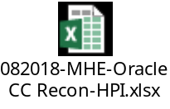

4.2 Credit card Bank transaction Extract
Once the receipts from Oracle are reconciled the next step is to extract the details from Paymentech ect. These receipts need to be reconciled to the bank statements. NOTE: the bank deposit in some cases is net of fees and chargebacks. The bank receipts need to be entered as Gross and then a line is added for fees and chargebacks. These extra lines are used to ensure that the matching between Oracle and the bank are gross. The discount and chargeback lines should be offset against the manual entries recorded to record the cc fees expense and the chargeback entry used to move the dollars to the chargeback account.
Refer to SOP “SOP_MHE_Braintree Monthly Report”, “SOP_MHE_Orbital Reports” and “SOP_MHE_PayPal Monthly Report” to get extract from Bank sites

4.3 Reconciliation to Atlas General Ledger
Reconcile all detail transaction the Atlas General Ledger. The file in total should total the amount of the posted monthly transaction.
Refer to SOP “SOP_Credit Card Cash Report” to know the matching process.

4.4 In a new worksheet add all the monthly detail items with 3 columns. All Oracle receipts will be given designated Oracle Type, bank transactions are noted as bank. Each should have the month, so you can follow the open items through the process. Example July Oracle, July bank.

The Columns should look as follows:

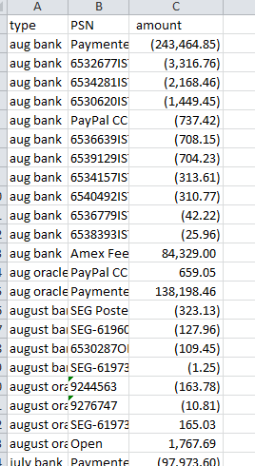

4.5-Prior month open items
All open items which were reported last month will be carried forward to the current month. Open the Reconciliation file of the previous month and insert a new sheet as the month Input and add all open items of the previous month, using your prior month reconciliation add lines to represent the open items. Make sure you have the correct types and months. This will help you review and resolve open items. Once complete total your file. It should agree to the g/l balance which is of previous month.

Then add the current month open items from the Reconciliation sheet prepared by consolidating the Bank and Oracle lines which matched with the current month PTD balance of the GL.

When we combine both previous month open items and the current month reconciliation lines then the total should tie to the YTD balance of the GL for the current month. If not you need to resolve that issue.

Note: Use the trim command on the PSN column to make sure all are in the correct format.

4.6 – Insert Pivot table

Once your file balances to the general ledger you can insert a pivot table. This table will match the items by PSN and provide the output by type
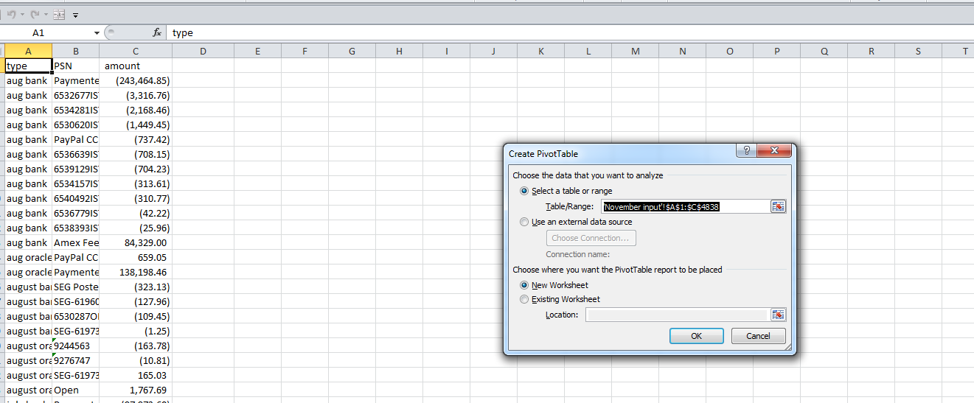

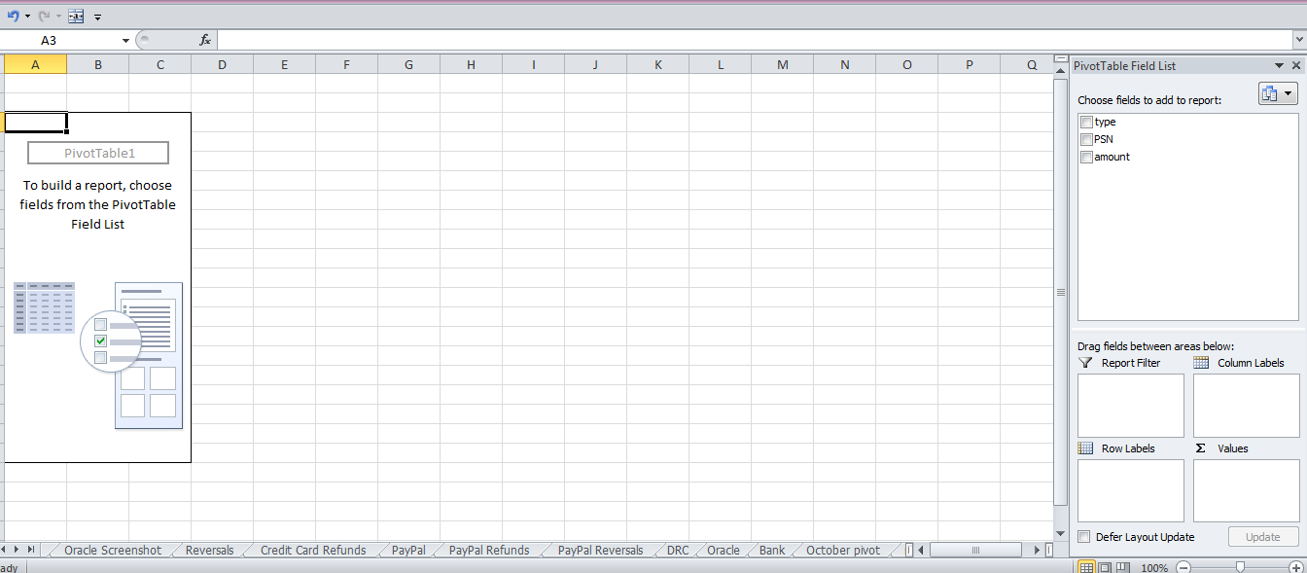
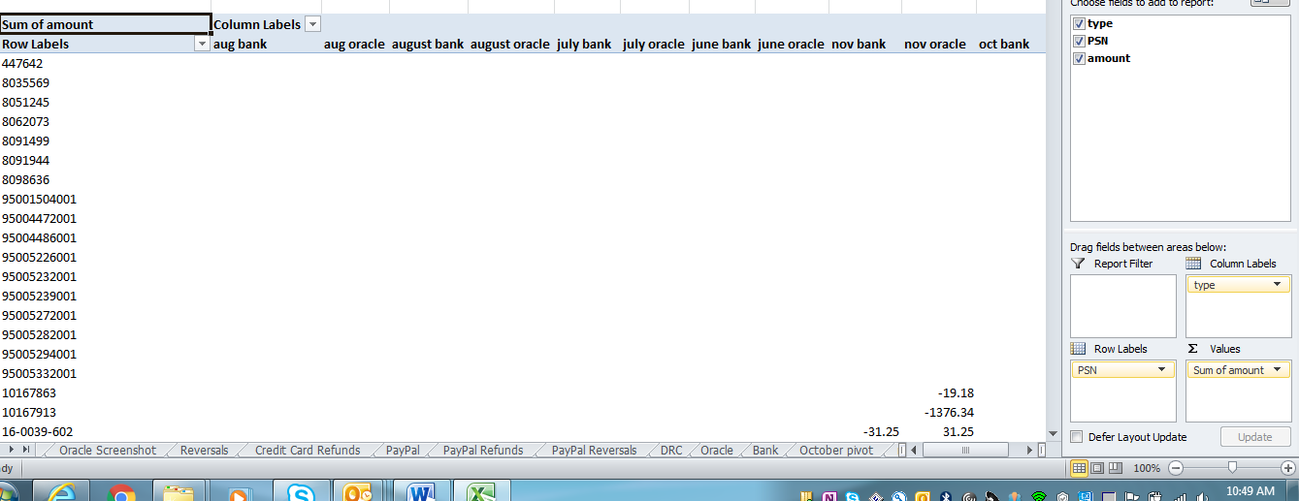

Remember Oracle will always be the first transaction as the receipt is created in Oracle prior to the settlement in the bank. The bank transaction will be second. Keep this in mind as you review your pivot table results.

4.7 Pivot table creation
Once the pivot table is created use the copy and past special values to change the excel worksheet into a useable file. Delete the pivot table once done.

4.8 Sort pivot output by grand total smallest to largest
You will then cut from the table and paste the items that net to zero into a new worksheet with sheet name “Offsets” this provides and audit trail and then delete the blank lines from your working file.

4.9 Sort Pivot by PSN number. This file represents the transactions that need to be reviewed and should also reconcile to the GL Balance. Look at the file and look for lines that need to be offset. Example on SEG DRC transactions should net to zero but there is a one to many relationship. Use the Text contains function to identify the DRC offset and cut and move to the offset worksheet. Continue to review open items to see if there are offsets. Once complete these are your working list to resolve.

4.10 – Resolving open items

►Amount in Oracle column debit no amount in the bank current month – timing
►Amount in Bank column credit no amount in Oracle –should not happen
►Amount in Oracle column credit no amount in bank column current month – timing
►Amount in prior month Oracle column but no bank amount – could be dummy credit card that needs to be reversed need to check the bank and Oracle and figure out where the issue is.

When the Reconciliation is complete you should not have any prior month open if you do it needs to be researched and resolved.

Credit card fee timing should equal the timing of the receipts usually about 2 days. Any other dollars should be reviewed and resolved to make sure that there was no issue with
the journal entry.

I store transactions – sometimes the receipt is in HPI but the bank is in SEG. You must record a manual entry to resolve this open item between the two reconcilations.

The reconciliation workbook should have all your tabs so you have a trail how you got to the open items. Include the previousl month pivot table in the file for tracking purposes.

This file once complete needs to be uploaded to Blackline as part of the reconciliation process.

  - Orbital Report from Paymentech Site
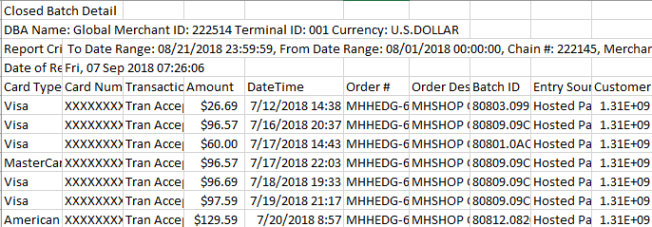

Refer to SOP: “SOP_MHE_Orbital Reports”.

  - PayPal report from PayPal Site

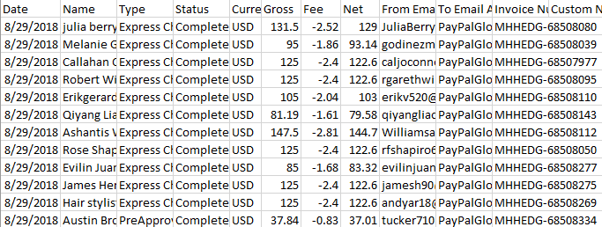

Refer to SOP: “SOP_MHE_PayPal Monthly Report”.

  - BrainTree report from Braintree site

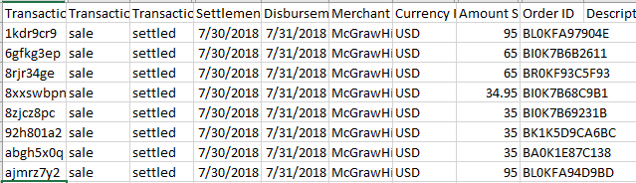

Refer to SOP: “SOP_MHE_Braintree Monthly Report”.

  - GL report from Oracle Express Transaction Analysis

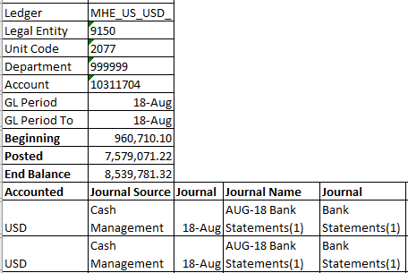
Refer to SOP: “SOP_MHE_Oracle Express Transaction Analysis”

  - Matching the Cash received in GL with the Cash settled in payment sites

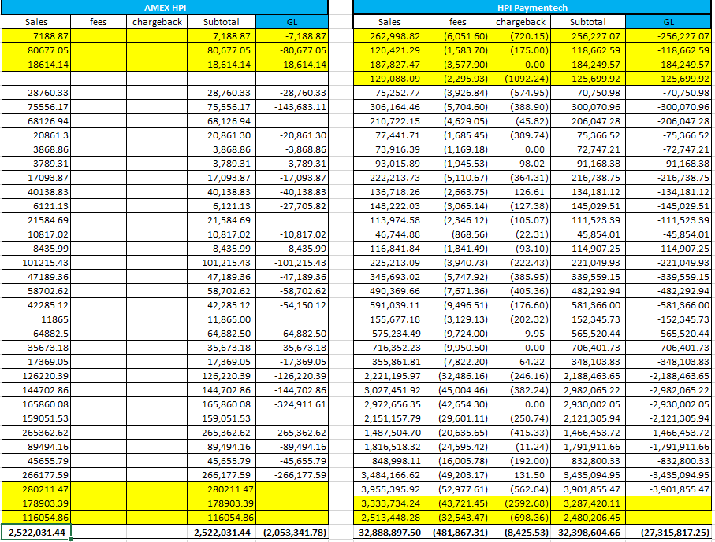

Refer to SOP: “SOP_Credit Card Cash Report”

  - Consolidate the data from Oracle Reports

Open the Excel file and open the detailed reports saved in the Shared drive on WD1 for all Credit Card payment methods and add sheets with name Sales, Refund, Reversals, CC Refunds, PayPal, PayPal Refunds, PayPal Reversals, Braintree, Braintree Refunds, Braintree Reversals.

For HPI:
Sales, Refund, Reversals, CC Refunds, PayPal, PayPal Refunds, PayPal Reversals, Braintree, Braintree Refunds, Braintree Reversals.

For SEG:
Sales, Refund, Reversals, CC Refunds, PayPal, PayPal Refunds, PayPal Reversals.

In these sheets the data which need to be considered for the CC Reconciliation should be in the data need to be entered only in the format mentioned.

From all sheet name Sales, PayPal and Braintree the following are the fields to be taken to be consolidated and name the sheet as Oracle which should tie out to the Sub-ledger balance:

- GL Date
- Payment Server Number
- Applied Amount

In the Refund, Paypal Refund and Braintree Refund sheet the following fields need to be taken:
- GL Date
- Payment Server Number
- Receipt Amount

From the sheet with names CC Refunds consider the Debit/Credit memo numbers in place of PSN, created in the Subledger account.

Consolidate all the required fields in one sheet with name “Oracle” and the total should match

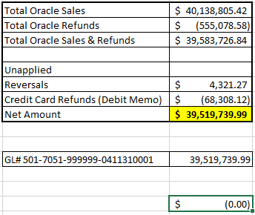

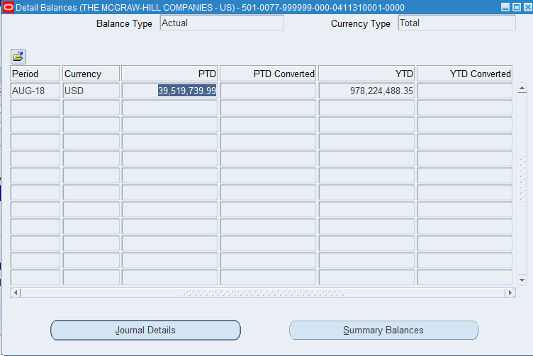

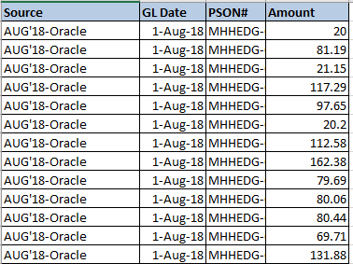

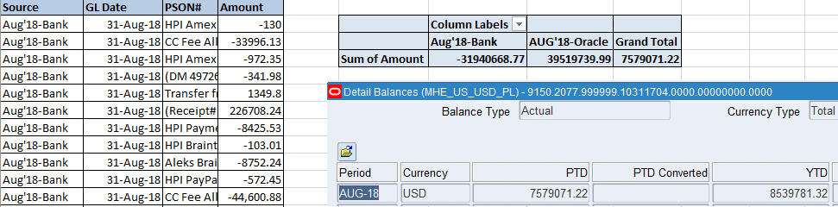

  - Reconciling and analyzing the outstanding balances with the open items with the reason

Once we get the information by running all the above queries in Access Database, we need to prepare the Reconciliation for the month using the previous months Reconciliation sheet as template.

Below is the screenshot of the 2018 August Reconciliation sheet for example:

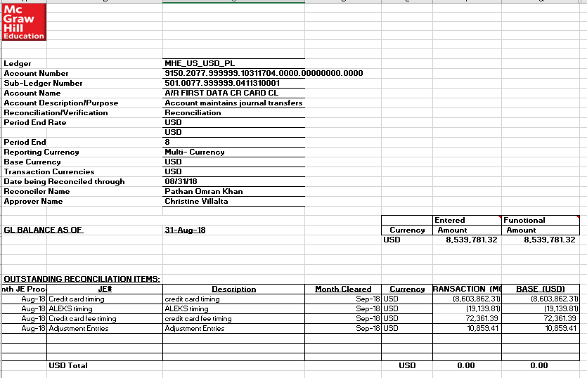

The above reconciliation sheet need to be included to the same excel file we are working on which has all the details that has associated to the reconciliation. All Reconciliation need to be submitted through Blackline on or before Preparers Due date

The following document gives more information on the Reconciliation template which was of 2018

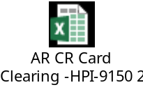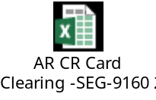

- Process Exceptions Handling
- None

- Compliance control

- Reconciliation must be completed monthly and uploaded to Blackline for review and approval
- All reconciling items need to be researched and resolved within 90 days.

- Escalation process

- System related issues would be escalated to IT helpdesk
- Process related issues would be escalated to Line manager.

First Level of Escalation:

Offshore-Genpact Manager-Bhavsar Parth-Parth.Bhavsar@mheducation.com

Second Level of Escalation:

Onshore-Director, AR Operations-Luckie Kathy-kathy.luckie@mheducation.com

- Process SLAs
- None

- Related Documents

- None

- FAQ:
- None

- Sign Off.
Kathy luckie 09/09/2020

